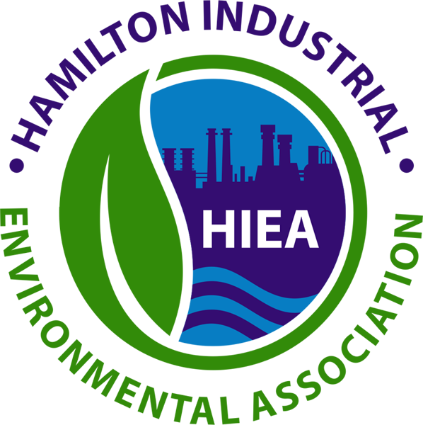
Technical Committee Meeting Minutes

Tuesday August 10th, 2021
9:30 to 11:30 a.m.

ZOOM Meeting

Attendees: Mike Brown (ArcelorMittal Dofasco), Parvaneh Chamaneh (Stelco Canada), Mike Cortese (ArcelorMittal Dofasco), Geoffrey Knapper (HIEA), Heidi Levitzky (HIEA), Graeme Clark (BWC Terminals), Gord Gilmet (Rain Carbon Canada), Aaron Posner (Posner Metals), Lori Small (Birla Carbon)

Regrets: Irene Boutilier (ArcelorMittal Dofasco), Albert Chang (Canadian Asphalt Industries Inc.), Mike Fancy (Triple M Metal LP), Bruce MacGregor (Air Liquide), Jasmine-El Salah (Lafarge), Rene Lemay (Bunge), Mark Lynch (Sanimax), Adam Ruys (AIM), Andrew Sebestyen (Stelco)

Action Items
New Actions
Ref. | Action Items | Status | Who | Due By
6. | Complete HIEA Surveys | In progress | All | Sept. 3, 2021
8. | Review and provide feedback re: HIEA Mission Statement and Key Messages |  | All | Sept. 3, 2021
9. | Review and provide feedback re: HIEA’s position statement on Climate Change |  | All | Sept. 3, 2021
10. | Research if there’s a Mohawk internship similar to Niagara’s available | - Env. Tech 2-year program has paid co-op term component  - Env. Mngt. On-line only  - HIEA has provided bursaries each year since 2006 to support students from: the Chemical Engineering Tech. - Environmental Program, the Env. Tech. Program with or without Co-op Internship and/or Energy Systems Engineering Tech. Program. | Heidi | Sept. 30, 2021
11. | Get logistics for on-site web traffic to Committee | Complete - Supports our desire for a simpler format with less material, but more relevant information. | Heidi | Sept. 30, 2021
16. | Vote for shorter, more frequent meetings | Submit vote here:  ^{https://linkto.run/p/EXRO0CGO}  ^{ONLY RECEIVED 4 VOTES} | All | Sept. 3, 2021

Welcome and Introductions

Review of Action Items from Last Meeting and Approval of the May Committee Meeting Minutes - Minutes were recommended for approval and seconded for acceptance by the group.

Community/Industry Guest: Chris Roik on Dust and Potential Solutions - Chris Roik is an interested member of the local business community located at Parkdale and Nikola Tesla. He has experience in Steel and Pipe and Tube moving aggregates and BF slag. He is a strong advocate for promoting actions to help keep the industrial areas clean of trackout / dust / dirt. He has experience from European sites that all heavy trucks are required to go through a truck wash before leaving the facility. He shared a video of one vendor of an innovative technology solution for wheel / truck washing, which could be adopted at a site in Hamilton if interested.

Financial Report – YTD Budget - the financial budget was presented. Largely most items are on budget. There was an overage due to legal advice required earlier in the year. At this point it did not appear that operating costs would exceed budget at year end. The budget review excluded the special scholarship at McMaster.

- Annual Meeting – Finalize Theme/Presenter
- Wednesday October 6th or 13th, 2021 – Update – Date will be October 20th
- 4:30 – 5:00 Board, 6:00 – 7:00 For Public Portion
- Requesting Technical Committee Presence
- Presenter – Richard Allen - Waste Heat Recovery Project
- Takeaways?

Geoffrey Knapper – Given the agenda time slot is short, it was recommended and supported by other committee members that we likely don’t need a theme.

Suggesting opportunities for promotional gifts / ideas to recognize attendees. Heidi has come across an organization who plants trees in Canada which we could contribute to. It was recommended we could make a selection on the type of tree and location. It would be ideal if we could contribute information on CO2 sequestered for various types trees. Suggested we could market the event as carbon-neutral. This was supported by committee members.

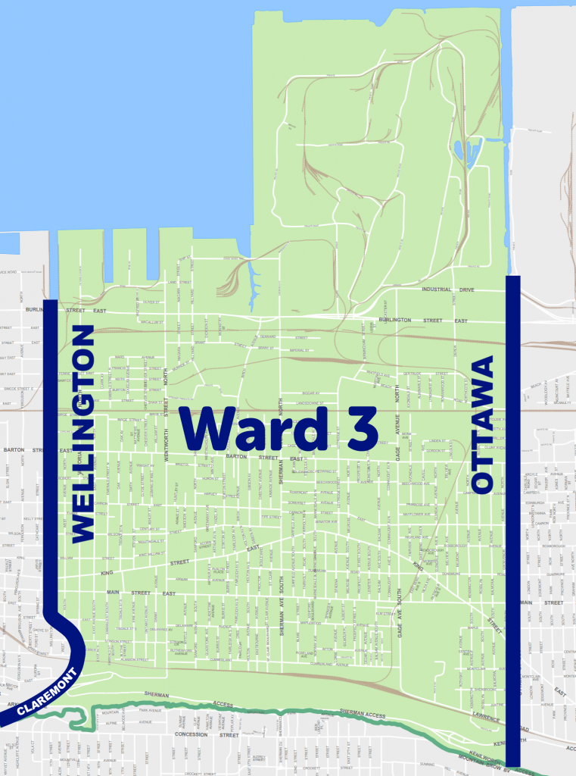

- HIEA Surveys - Data required for 2020 data on water, air, waste metrics and any company metrics (size, acreage, employees etc.). Data is confidential. Due date is September 3rd. Some have been received to date. Heidi and Geoff are available to help.

- Odour Discussion and Ward 3 Community Meeting Re-cap - Geoffrey Knapper
Had a discussion with Councilor Naan and Kerry LeClair to talk about issues in the ward. Ward 3 is around Air Liquide area and goes south. Councilor Naan and Kerry expressed frustration resolving issues in their ward. Feels that the MECP is not active enough in resolving complaints / issues in the ward. And asking for support from HIEA to help.

Asking for help from HIEA members to help address issues their residents might be dealing with. Geoff reviewed with the Board and Heidi. Proposal: Resident would submit the form to the HIEA operations and then HIEA would follow up with the specific companies as needed and close the loop with the residents. HIEA members were generally supportive of having HIEA act as an area to receive complaints and follow up with the appropriate HIEA members who most likely would have possibly contributed to the incident to check the operations for feedback.

- HIEA Key Messages - Heidi has proposed an updated mission statement that reflects the current direction and context of HIEA. She will forward a copy of the updated document to members and asking for feedback from members by September 3rd.

- HIEA’s Position Statement on Climate Change - Geoffrey Knapper presented a proposal on HIEA’s commitment to climate change, for review by members and comments before finalization. Due date will be September 3rd.

- Niagara College Next HIEA Intern Project Ideas (Jan – Apr. 2022)
- A world without steel (Disease, unemployment, economic collapse, etc.)
  - Could make a banner to bring to public events along with updating the other HIEA banners – generally voted against
- Modernize the Hamilton Children’s Water Festival Activities (i.e., the role of water in biodiversity) Suggestion: * make it more industrial – once through cooling, water conservation, water separation and filtration effect of coagulants on clean water. By city or industry before makes it way back to water, cleaned up, re-processed, and a hands-on event.
- Air Quality in Hamilton spring 2020 – COVID impacts (see if a reduction in traffic correlates with HAMN data) Question: Air quality around highways – during that period, was there a reduction in production? Birla yes, AMD yes, Surveys has this info. Wouldn’t showcase those reductions were driven by non-industrial sources.
- Annual report synthesis
- Member spotlight for social media? Individual interviews on-site?
- Others?

* Feedback from the committee was if we can review the water festival to update the content with a component that focuses on industrial wastewater treatment, with hands on experiments that illustrate how water is cleaned before discharge to the environment.

Suggested as well that HIEA follow up with Mohawk Collage to see if an internship position would be suitable from their site as well.

- Website Modernization - Currently the website is somewhat out of date.
- Estimated cost (minimum) to refresh and update the content would be $3,000 including a mix of content, data, and information as well as look and feel. Currently we have 32 pages, which might be too many.

Key point is if the site needs to be updated regularly as a “designation site” designed to draw people to it, or more of a static site (like a business card where people go for information) with less changes

Question was raised about the traffic we receive? There is not a lot of traffic / day to day. This work will take place in 2022, so feedback from the group is being requested.

Heidi to send current site logistics to Committee.

- McMaster University Sustainable Chemistry Mini-Celebration and Potential HIEA Involvement - Look at providing their students with real-world problems that individuals or groups could address over the course of a semester with a report. They are chemistry focused individuals (1st, 2nd, 3rd year students). Looking to get them internship experience with without being in a formal internship. This is more of a research / remote opportunity for them to investigate / help resolve. If any company is interested Geoffrey can provide contact information – get in contact with Geoffrey.

- Truck Route Master Plan - Heidi has provided feedback on the proposed truck route changes. Of most significance is the plan to limit some roads to only 7 AM to 7PM. Feedback from HOPA and the Ontario Trucking Association suggests that many trucks prefer to drive outside of the core rush hour period to avoid congestion etc.

- Employment Ontario Partners Gateway (EOPG) – Funding Available for Hamilton Businesses
Ontario job grant program support re-skilling of employees. If a company is interested training 5/6th of costs for re-skilling of employees is covered by this project. Heidi has more information on this.

- Safety and Environmental Issues Discussion - no discussion

- Round Table - Lori shared information on a noise monitoring tool Birla is using help address noise complaints. The software is installed and run by third party – Soft DB. It records so can go back and check when a complaint comes in and can send file to MECP.

- It was recommended that more frequent meetings of shorter length be proposed as opposed to fewer longer meetings. This was generally supported by the committee.

- Adjournment – next meeting – November 9th

